1. Open Server, Client

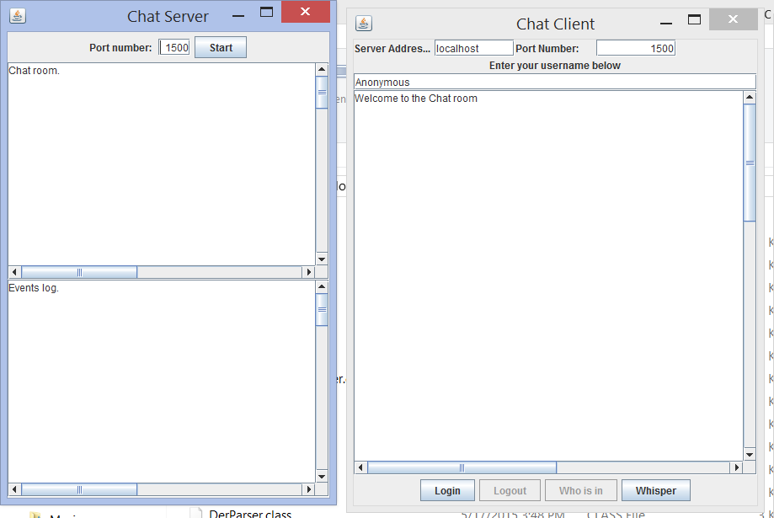

1. Start server

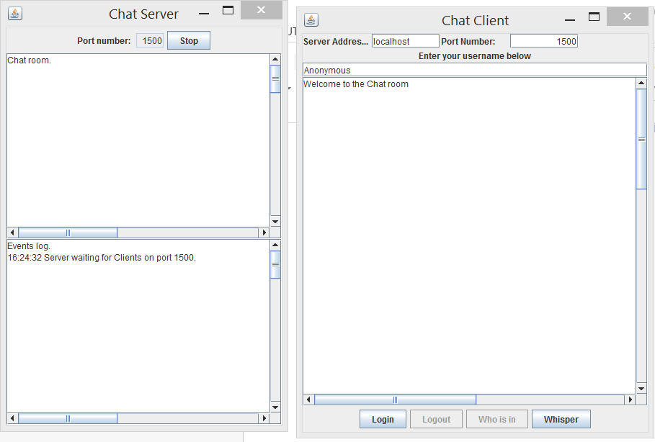

1. Client connect to server

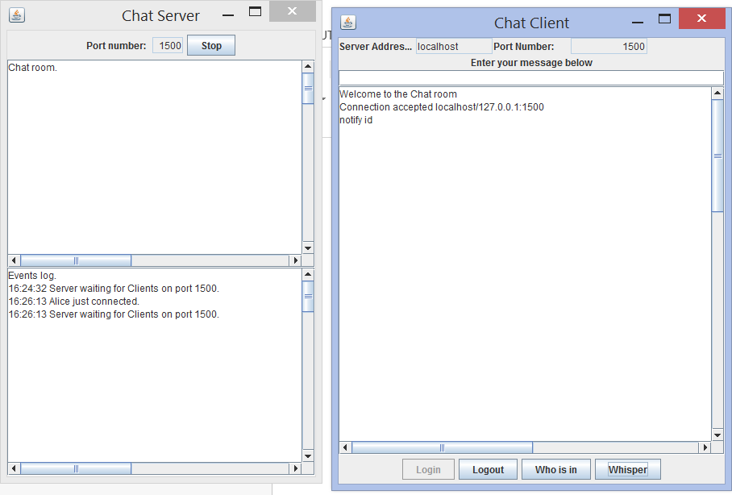

1. Chat room chatting

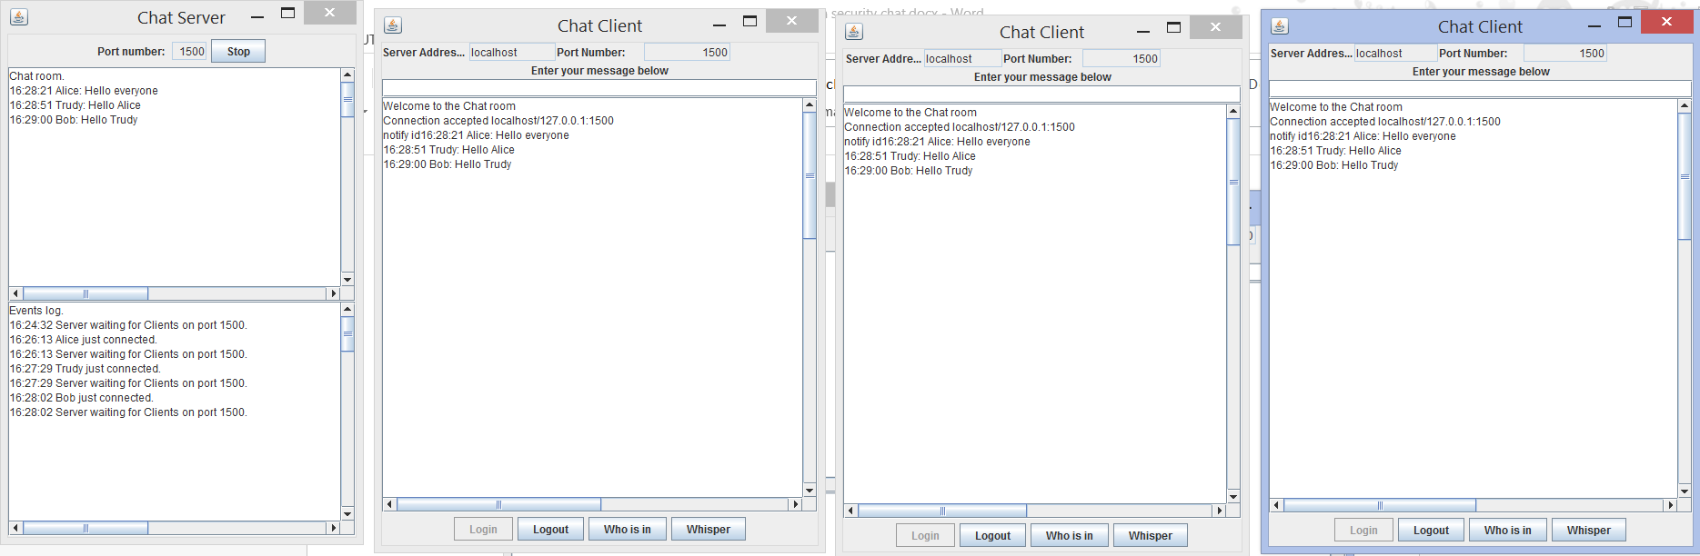

1. Get Online User list(click Who is in Button)

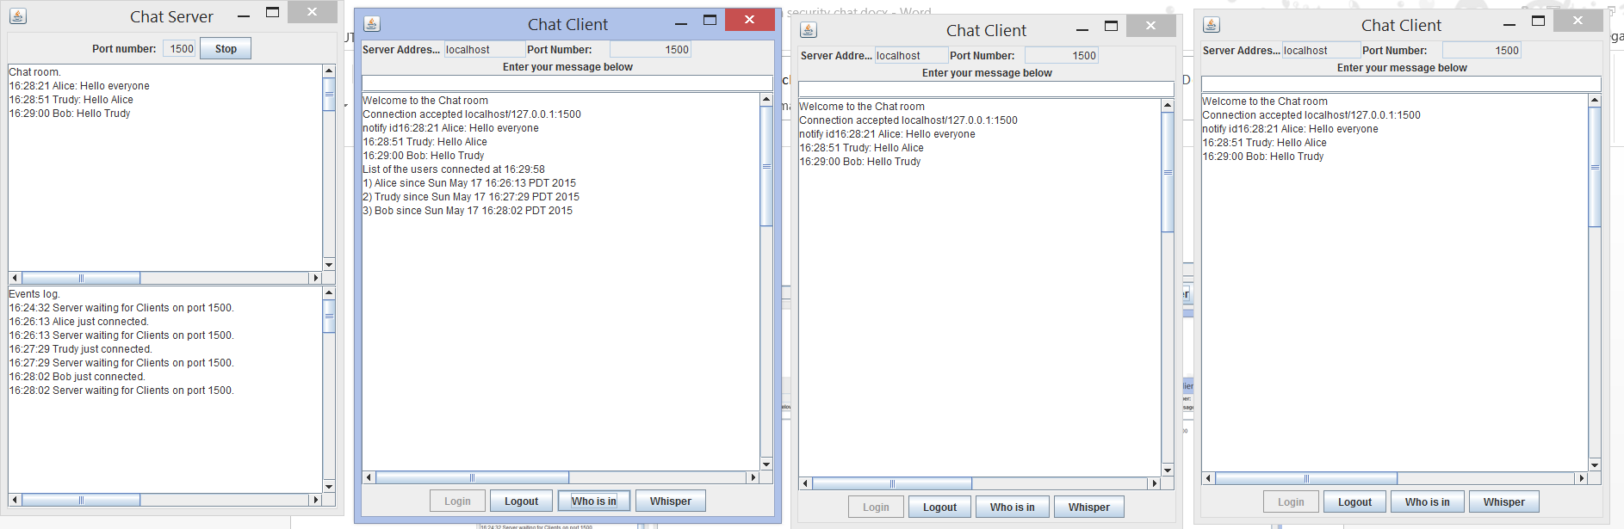

1. Start secure chat(click whisper)
2. Send whisper chat request to sever,
3. Sever generate DES key (as session key for secure communication)
4. Encrypt DES key with user’s public key,
5. Server send encrypted key to users,
6. Users receive session key, decrypt it with their private key
7. Finally, they could use this session key to encrypt/decrypt message.

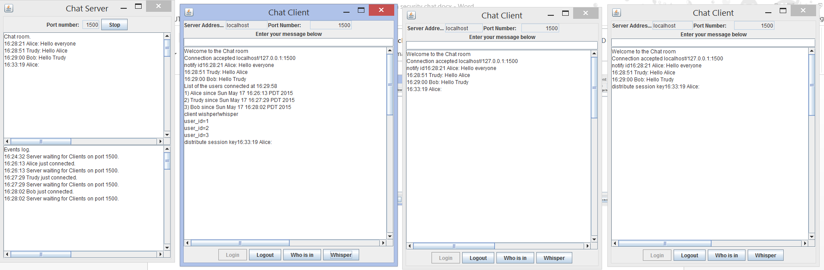

1. Secure chat

Now Alice could talk to Bob securely.

They encrypt their message with session key before send, decrypt the message received from his others with session key.

